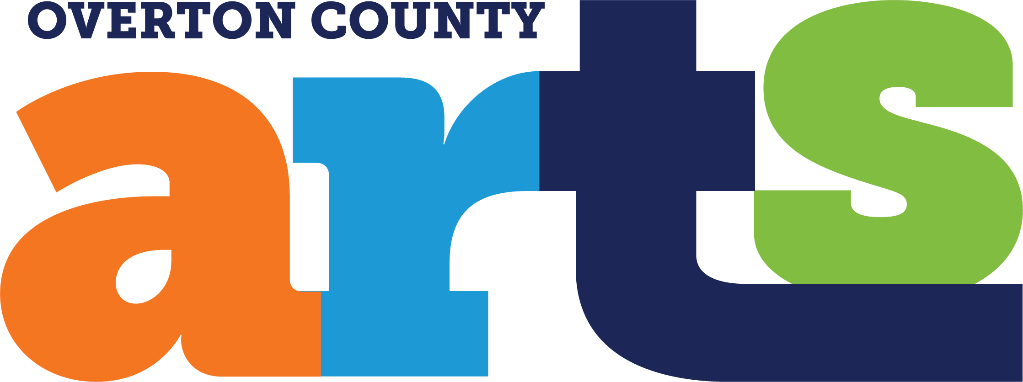

Inaugural Paint Livingston Plein Air Competition October 3-5, 2024
Livingston, TN
Participating Artist Prospectus

PaintLivingston.com

REVISED & UPDATED: 8-24-24

Artist registration deadline: September 15, 2024 Registration is now closed. We already have 38 artists signed up from Knoxville, Nashville and throughout the Upper Cumberland area. This is fantastic and we are thrilled with the response to our inaugural event. We had to cap the number of artists at 38 to ensure that our juror will be able to fairly assess all the artwork that will be submitted for the competition. There are other logistical considerations that have led us to this decision, too. If you want to put your name on a standby list, please email us at info@overtoncountyarts.org.

Artist registration fee: $35, non-refundable.

Total prize money: $3,450

Prizes for plein air competition:
First place: $1,000
Second place: $700
Third place: $400
Honorable Mention: $200

Prizes for Quick Draw competition:
First place: $500
Second place: $350
Third place: $200
Honorable Mention: $100

About Livingston, Tennessee:
Livingston, TN is small town (population 4,000) located in north central Tennessee and is known for its friendly people, picturesque town square and surrounding natural beauty, including bucolic farms, verdant rolling hills, Dale Hollow Lake and historic Standing Stone State Park. Driving times to Livingston from nearby larger cities are:
- Nashville, TN: 1 hour and 30 minutes
- Chattanooga, TN: 2 hours
- Knoxville, TN: 1 hour and 45 minutes
- Lexington, KY: 3 hours
- Louisville, KY: 3 hours
- Bowling Green, KY: 2 hours
- Huntsville, AL: 3 hours
- Atlanta, GA: 3 hours and 45 minutes
- Asheville, NC: 3 hours and 45 minutes
Paint Livingston is presented by the Overton County Arts Council (OCAC). Founded in 2024, the OCAC is a 501(c)3 nonprofit organization. Our mission is to cultivate and promote the visual arts for all residents and visitors of Overton County, TN. We offer events, classes and exhibitions focused on the visual arts, and more. To learn more about OCAC, visit us online at OvertonCountyArts.org.

Juror: Connie Erickson. Connie began her professional portrait painting career in 1987, after a period of extensive study with Daniel Greene and several other well-known artists.

She works in oil and pastel and has exhibited in numerous juried exhibitions and solo shows. She has received many awards for her portrait, still life, and landscape paintings. She was a finalist in The Artist Magazine national contest in the portrait division in 1994, and won Honorable Mention in the American Society of Portrait Artists competition in 1996 in Montgomery, AL. In June 2000, she won Honorable Mention in the American Society of Portrait Artists Festival at the National Academy of Design and Metropolitan Museum of Art in New York City. In 2004, she won a Certificate of Merit with her portrait of Dylana in the Portrait Society of America Competition in Boston. She was commissioned by the Daughters of the American Revolution to paint the portraits of three different DAR presidents.

Connie taught at Watkins Institute College of Art in Nashville, Cheekwood Fine Arts Center in Nashville, gives workshops, and teaches privately. She is former president of the Nashville Artists Guild. She is a member of the Portrait Society of America, The Pastel Society of the Southwest, The Outdoor Painters Society, and a signature member of the Pastel Society of America. Her work includes academic, corporate and private commissions. Connie helped found and was elected first president of The Chestnut Group: Plein-Air Painters for the Land in Nashville, Tennessee. To learn more, visit www.connieericksonstudio.com.

Competition rules:

The competition is open to all artists. We expect to have both experienced, working artists who have participated in other plein air competitions and amateur artists who have not yet done so.

Paintings in acrylic, oil, watercolor, pastels, and gouache will be accepted. We hope and expect to have between 15-25 participating plein-air artists for this first year of the event. Canvases will be date stamped at the beginning of the overall competition and for the separate Quick Draw event on Saturday afternoon to ensure compliance with competition rules.

Name badge / lanyard should be worn by all participating artists while painting and during festival events.

Painting locations will be designated in or near downtown Livingston. Locations will include the historic courthouse square, nearby farmland, Standing Stone State Park, and Dale Hollow Lake, all within a 30-minute drive of downtown. Inclement weather plans will ensure that the event proceeds regardless of the weather.

Artwork will be limited to any size up to 20” x 20” and must be created in the field during the event. There is no minimum required size. Each participating artist must submit at least one painting and no more than three paintings for the competition and exhibition. We hope that each artist will submit three paintings, if possible. The OCAC reserves the right to decline artworks that do not fall within the defined scope of this competition or are deemed inappropriate. Entries that do not adhere to all guidelines will not be judged.

The deadline to turn in competition paintings, framed and ready to hang for the Saturday exhibition, is 9am Saturday, Oct 5 at the exhibition venue downtown, which is the Millard Oakley Public Library located on the courthouse square at 107 East Main Street, Livingston, TN 38570. Artists provide their own frames and must be prepared for wet paint installation. If necessary, assistance or other accommodations may be made for newcomers to competitions like this who may have trouble with proper framing for exhibition. Artwork must be delivered for exhibition Sat morning up until 9am with proper labels, tags, etc. All art will be on display to the public from 12pm-4pm Saturday, Oct 5. The OCAC reserves the right to use photographs of all submitted paintings and all participating artists in its own marketing and public relations efforts.

Participating artists are encouraged to attend the Opening Reception & Dinner with OCAC members and patrons on Thursday, Oct 3 from 5pm-8:30pm, the Friday evening Reception & Dinner with OCAC members and patrons from 5:30pm-8:30pm and the Closing Reception and Award Ceremony on Saturday, Oct 5 from 1:30pm-2pm at the Millard Oakley Public Library on the courthouse square. All receptions and dinners are free for participating artists and one guest.

The OCAC will receive 20% of all sales of artwork transacted during the event. Transactions will be handled by OCAC staff and disbursements of funds will be made to all artists as soon as possible via common electronic transaction apps like Square, Venmo, etc. Any unsold paintings in the event exhibition must be picked up Saturday night by 4pm. The OCAC is a 501(c)3, tax-exempt nonprofit corporation. Selling artists and buying customers should check with their own professional advisors to determine if, and how much of, their 20% commission on transactions may be considered tax-deductible contributions to the OCAC.

It is recommended that artists price their work in the range of $250-$750. All transactions must be handled by event staff.

Quick Draw Competition:

There will be a separate Quick Draw Competition on Saturday, Oct 3, from 9:30am-11:30am. All artists who are part of the main competition are expected to compete in the Quick Draw competition, if possible. The Quick Draw event will be held in or near the downtown courthouse square.
Together, artists and spectators will be immersed in the creative process during this Quick Draw event. At 11:30am, artists should take their paintings to the Millard Oakley Public Library located on the courthouse square at 107 East Main Street, Livingston, TN 38570. Event volunteers will help display all Quick Draw work. The work will be judged and then offered for sale to the general public. Quick Draw awards will be announced at this location at 1:30pm, along with the awards for the main Paint Livingston competition.
Housing & Hospitality:

Some limited discounted Airbnb accommodations may be available to participating artists on a first-come, first served basis. Discounts TBD and specific to each property. In addition to all the lodging available in Overton County, there are good hotels and many more AirBnB properties in nearby Cookeville, TN, too. For more information about and assistance with lodging, contact us at info@overtoncountyarts.org.

Artists and one guest are invited to eat and drink at all OCAC sponsored receptions and dinners for free. Other efforts will be made to ensure that all artists are well-fed and hydrated throughout the event.

Event Schedule
Thursday, Oct 3: 6-10am Artist welcome & check-in. Pastries, coffee, juice, etc. provided.
To-go picnic box for lunch available.
All day Painting around town, nearby farm, state park and Dale Hollow lake.
5-8:30pm Reception and dinner. Meet & greet with OCAC patrons and members.
Artists are encouraged to attend.

Friday, Oct 4: 6-9am Light breakfast buffet available to artists. To-go picnic box for lunch
available for pick up.
All day Painting around town, nearby farm, state park and Dale Hollow lake.
5:30-8:30pm Reception and dinner. Meet & greet with OCAC patrons and members.
Artists are encouraged to attend.

Saturday, Oct 5: 7-9am Light breakfast buffet available to artists.
8-9am Framed art turned in by artists at library. Art hung by event staff.
9:30-11:30am Quick Draw competition on or near courthouse square.
12-1:30pm Lunch break for artists.
1:30-2pm Main competition and Quick Draw winners announced.
9am-2pm Chalk art demonstration and family activities on square.
12-4pm Public exhibition and art sale for competition paintings and Quick Draw paintings.
2-4pm Closing artist reception open to public
4pm All sales completed, and settlements made, if not done already.

For more information, please visit PaintLivingston.com or contact Overton County Arts president Tim at info@overtoncountyarts.org

